CONVERT THE EXPRESSION FROM INFIX TO POSTFIX: -
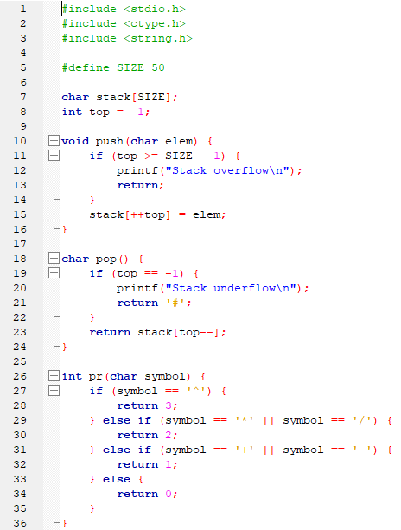
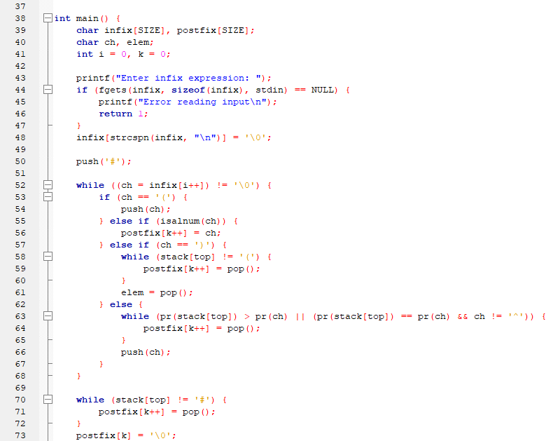
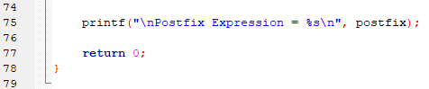

OUTPUT: -
